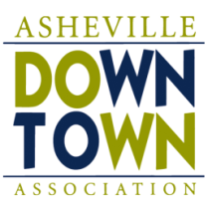
2014 Downtown After 5 Nonprofit Selection Form – Wristband Sales

Name of Nonprofit:
Sponsoring ADA Board Member:
Mailing Address:
Primary Contact:
Phone Number:
Email Address:
501 c (3)? | YES NO
ADA Member: | YES NO
Charitable purpose or use of proceeds:
The group’s connection to Downtown Asheville:
Preferred Date (mark 1st and 2nd choice):
_____May 16 _____June 20 _____July 18 ______August 15 ______September 19
If selected, your group agrees to the following terms:
- You will have at least 26 individuals, over 18, available to work in two shifts (16 – 1st shift, 10 – 2nd shift). These shifts run from 4:45-7:00 and 7:00-9:15.
- Failure to provide the minimum number of volunteers per shift will result in your organization forfeiting 25% of your proceeds and may result in your organization becoming ineligible for future event considerations.
- The individuals volunteering agree to abide by the ADA rules for wristband sales.
- Your group will split the wristband revenues with the ADA (50/50) up to a maximum of $2,000.
Primary Contact’s Signature:

The deadline for the application is February 7th.
The charities will be selected on February 12.

